C-WITHOUT LPM3

#include <msp430xG46x.h>

/*Ron ben david*/

/*Yohav itzhak*/

/*Ben Reuven, */

void main (void)

{

P1DIR = 0x030;

P1SEL = 0x030;

while(1);

} 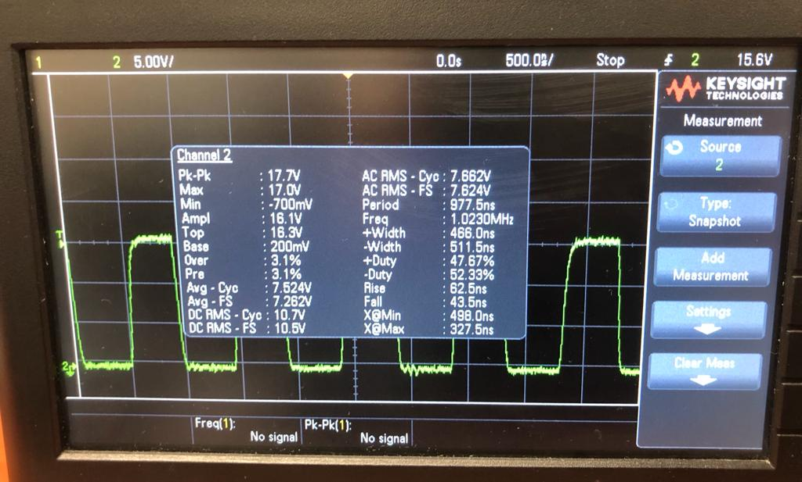

C-WITH LPM3

#include <msp430xG46x.h>

/*Ron ben david*/

/*Yohav itzhak*/

/*Ben Reuven*/

void main (void)

{

P1DIR = 0x030;

P1SEL = 0x030;

_BIS_SR (LPM3_bits + GIE);

while(1);

}

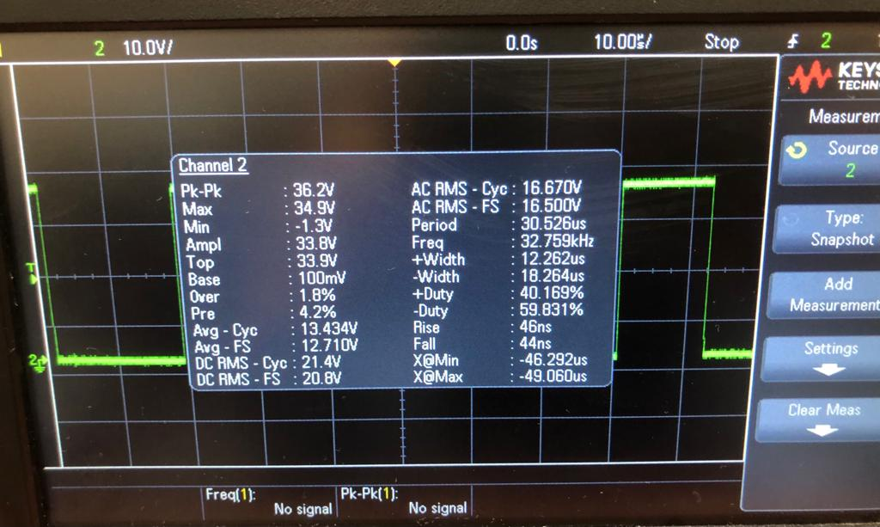

**ASM-WITHOUT LPM3**

#include <msp430xG46x.h>

/*Group #7 */

/*Ron ben david*/

/*Yohav itzhak*/

/*Ben Reuven*/

;-------------------------------------------------------------------------------

RSEG CSTACK ; Define stack segment

;-------------------------------------------------------------------------------

RSEG CODE ; Assemble to Flash memory

;-----------------------------------------------------------------------------

RESET mov.w #SFE(CSTACK),SP ; Initialize stackpointer

StopWDT mov.w #WDTPW+WDTHOLD,&WDTCTL ; Stop WDT

SetupP5 bis.b #030h,&P1DIR ; P5.1 output

bis.b #030h,&P1SEL ; P5.1 output

;

Mainloop

jmp Mainloop ; Again

;------------------------------------------------------------------------------

COMMON INTVEC ; Interrupt Vectors

;------------------------------------------------------------------------------

ORG RESET_VECTOR ; MSP430 RESET Vector

DW RESET ;

END

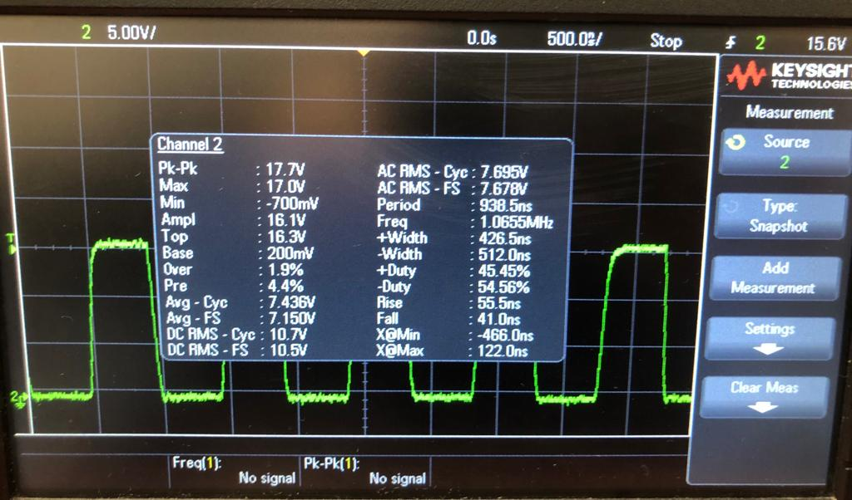

**AMS-WITH LPM3**

#include <msp430xG46x.h>

/*Group #7 */

/*Ron ben david*/

/*Yohav itzhak*/

/*Ben Reuven*/

;-------------------------------------------------------------------------------

RSEG CSTACK ; Define stack segment

;-------------------------------------------------------------------------------

RSEG CODE ; Assemble to Flash memory

;-----------------------------------------------------------------------------

RESET mov.w #SFE(CSTACK),SP ; Initialize stackpointer

StopWDT mov.w #WDTPW+WDTHOLD,&WDTCTL ; Stop WDT

SetupP5 bis.b #030h,&P1DIR ; P5.1 output

bis.b #030h,&P1SEL ; P5.1 output

;

Mainloop

BIS #GIE+CPUOFF+SCG1+SCG0,SR

jmp Mainloop ; Again

BIC #CPUOFF+SCG1+SCG0,0(SP) ; Exit LPM3 on RETI

RETI ;

;------------------------------------------------------------------------------

COMMON INTVEC ; Interrupt Vectors

;------------------------------------------------------------------------------

ORG RESET_VECTOR ; MSP430 RESET Vector

DW RESET ;

END

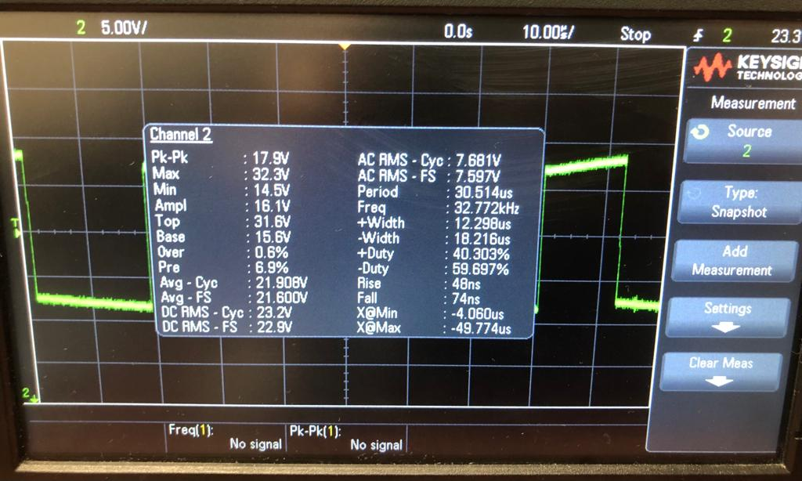

**ההוראה LPM3**

מורידה את תדר השעון מתדירות 1Mhz לתדירות שעון של 32Khz

ומכאן מגיע המעבר מבין ACLK לSMCLK בהתאמה.

קבוצה #7 מגישים:

רון בן דוד

יואב יצחק

בן ראובן